COIL Group 5

Gloria van Trigt and Nazdar Sadik

10/18/2022

Free3Dm Documentation Plan—  
E-Commerce Website  
version 1.0



Contents

1. Introduction 4

1.1 Project Roadmap 4

1.2 Content Purpose 5

1.2.1 UI Content 5

1.2.2 Online Tutorial 5

1.2.3 Printed Catalogue 5

1.3 Content Scope 6

1.3.1 UI Content 6

1.3.2 Online Tutorial 6

1.3.3 Printed Catalogue 7

1.4 Target Audience 7

1.4.1 User Persona 1: The Beginner 8

1.4.2 User Persona 2: The Hobbyist 10

1.4.3 The Specialised Business Owner (User Persona 3) 12

2. Deliverables 14

2.1 List of Content Deliverables 14

3. Content Overview and Organisation 14

3.1 UI content 14

3.2 Tutorial 16

3.3 Catalogue Organisation 16

4. Content Strategy 17

4.1 Usability 17

4.1.1 Usability Goals 17

4.1.2 Usability Testing 18

4.1.3 Usability Criteria and Measuring Success 19

4.2 Accessibility 20

4.2.1 Web Content Accessibility 20

4.2.2 Printed Catalogue Content Accessibility 21

4.3 Single Sourcing 21

4.4 Localisation 22

4.4.1 Localised Content Standards 22

4.4.2 Converting Labels 22

4.4.3 Converting Units of Measurement 23

4.4.4 Localisation Resources and Costs 23

5. Specifications 23

5.1 Platforms 23

5.2 Tools and Equipment 24

5.3 Design Implications 25

5.3.1 Website Design Implications 25

5.3.2 Writing Tone 26

5.4 Graphics 26

5.4.1 Website Graphics 26

5.4.2 Printed Catalogue Graphics 26

5.5 Delivery Format 27

5.6 Style and Terminology 27

6. Project Schedule 28

6.1 Project Milestones 28

6.2 Reviews and Approvals 29

6.3 Production and Distribution 31

6.4 Maintenance and Change Control 32

7. Resources 35

7.1 Technical Writers 35

7.2 Stakeholders and Cross-Functional Team 38

7.3 Subject Matter Experts 40

8. Dependencies 41

9. Risks and Issues 41

10. Documentation Plan Revisions 42

11. Appendix A 43

11.1 Terminology List 43

# Introduction

This documentation plan outlines the categories of content that the Technical Communication department will provide for the version 1.0 release of the Free3Dm e-commerce website and the timelines and dependencies for each category. Note that a separate documentation plan is required for all released versions of the website.

## Project Roadmap

Free3Dm’s e-commerce website will provide customers from many backgrounds and skill levels (from beginner to business-use) with everything they need for their 3D printing projects. It will serve as a one-stop place for users’ 3D printing needs as it will provide printers, printing materials, accessories, and options for each discrete audience.

Free3Dm’s audience includes the Beginner, the Hobbyist (intermediate level), and the Specialised Business Owner (expert level). See 1.4 Target Audience for the complete user personas. Though these personas have different needs based on their backgrounds, they share values that the user interface (UI), web copy, tutorial, and catalogue will address. The Free3Dm audience values a professional and trustworthy experience that meets their needs in an easy and accessible way.

The project’s purpose is to present 3D printing, a disruptive new way of printing, as an activity that anyone can do at any level while providing welcoming, trustworthy, and professional services that are intended for people of all technical skill levels.

The web content will support the project’s purpose by using plain, clear, and concise language to promote the user journey and meet the needs of the users.

The online tutorial will support the project’s purpose by providing a clear introduction to the most important aspects of the e-commerce website. Users will have the choice to skip or rewatch the tutorial based on their unique needs.

The printed catalogue will support the project’s purpose by reflecting the brand style guidelines, voice, and tone. It will consider the needs of the discrete audiences in the organisation and navigation of the content. Further, the printed catalogue will be available as both a print and PDF version in consideration of how the audience will use it in different contexts.

## Content Purpose

The Free3Dm Technical Communication team will produce UI and web content, an online tutorial, and a product catalogue. This section outlines the purpose of each.

### UI Content

The audience of the UI and web content is all site users. Therefore, the UI content must support the Free3Dm’s goals by using professional, clear language that considers the various experience levels of the audience.

The UI content facilitates the user journey with accurate language for navigation, buttons, error messages, and all other UI aspects.

The web copy enhances the user experience by providing the information they need to find the products that fit their needs, make a judgement on the company, and make a purchase. The web copy includes product descriptions; information about the company, returns, shipping, and customer service; and basic articles, like the getting started guide.

Much of the content is stand-alone. The product descriptions will be re-used in the printed catalogue.

### Online Tutorial

The audience of the tutorial is all first-time visitors. Because it cannot target an audience beyond first-time visitors, it must provide a welcoming, efficient, and effective introduction to the site that draws users in to continue exploring. The tutorial must not be a barrier to users, so there will be a skip option for users that do not want to watch it.

The tutorial is stand-alone content as there will be no other training required to use the website. However, users have the option to rewatch it if needed. The tutorial supports the navigation and tooltips that are designed for a smooth, intuitive user journey.

The tutorial supports the project’s purpose by giving the users the tools they need to successfully navigate the site and make purchases.

### Printed Catalogue

Since Free3Dm’s audiences have separate needs, the catalogue must deliver the most relevant information to the relevant audience. The catalogue will use single-sourcing principles to deliver different versions to the right audiences.

The main audience of the catalogue is the specialised business owner as they are likely to keep it in their office as a reference point. In addition to single sourcing, the catalogue will be optimised for business use by highlighting speciality products and their uses and by highlighting bulk ordering.

The catalogue is not the user’s only source of information. It will provide similar information to the web copy, particularly the product descriptions. The catalogue supports the different contexts of use.

## Content Scope

This section defines the scope of each content deliverable the Technical Communication team will produce for the version 1.0 release.

### UI Content

The UI content will cover:

* + - All aspects of the UI (buttons, pop-up messages, error messages, menus)
    - All web content (product descriptions, company contact information, About Us, Terms and Conditions, Return policy, Warranty policy, frequently asked questions)
    - Basic getting started guide for beginners
    - Basic marketing information (for example, the spotlight section of the landing page will include copy like “All resins are 15% off”)

The UI content will not cover:

* + - Blog articles
    - Guides or web content for administrator users
    - Additional marketing content

The documentation will not cover administrator topics as the focus of the content is on the customer experience and the usability of the site from the customer perspective.

Additionally, to limit the scope of the version 1.0 release, the Technical Communication team will not create blog articles or additional marketing content.

### Online Tutorial

The tutorial will cover the aspects of the customer journey, including:

* + - Navigation
    - Filtering products
    - Creating an account
    - Making a wish list
    - Adding an item to the shopping cart

The tutorial will not cover:

* + - The checkout process
    - Any admin uses of the site
    - Making a return

The tutorial’s purpose is to introduce users to Free3Dm’s website navigation and products. The tutorial focuses on setting up the user to easily navigate the website and find the products they need. The user personas have experience using e-commerce websites and do not need guidance with basic site interactions.

### Printed Catalogue

The catalogue will include:

* All products from all categories on the website
* Shorter versions of each product description
* Basic introductory text for each category
* Copyright information
* A short blurb about the company
* A table of contents
* An index

The catalogue will not include:

* + - Ideas for how to use products or recommended projects
    - Order forms

The catalogue is a reference tool and will not be as detailed as the web copy. The main audience is the specialised business owner who has an expert-level knowledge of the products and will use the catalogue for reference.

## Target Audience

There are three main user personas that have been outlined for this project: the Beginner, the Hobbyist, and the Specialised Business Owner. Together, these user personas make up the target audience for the Free3Dm e-commerce website. The user personas are displayed in Figure 1, Figure 3, and Figure 5. The respective customer journeys are displayed in Figure 2, Figure 4, and Figure 6.

### User Persona 1: The Beginner

The Beginner user has goals to purchase a low-budget 3D printing starter kit to create basic and fun projects. They have no previous experience in 3D printing and are eager to learn more about what they can create with the tools Free3Dm provides. The Beginner would also like to understand the different types of printing materials available so that they can start 3D printing. Since many 3D printing e-commerce websites are very technical and geared towards professionals, this user would like to find an easy place to start on their 3D printing journey. More details about the Beginner user persona are shown in Figure 1.

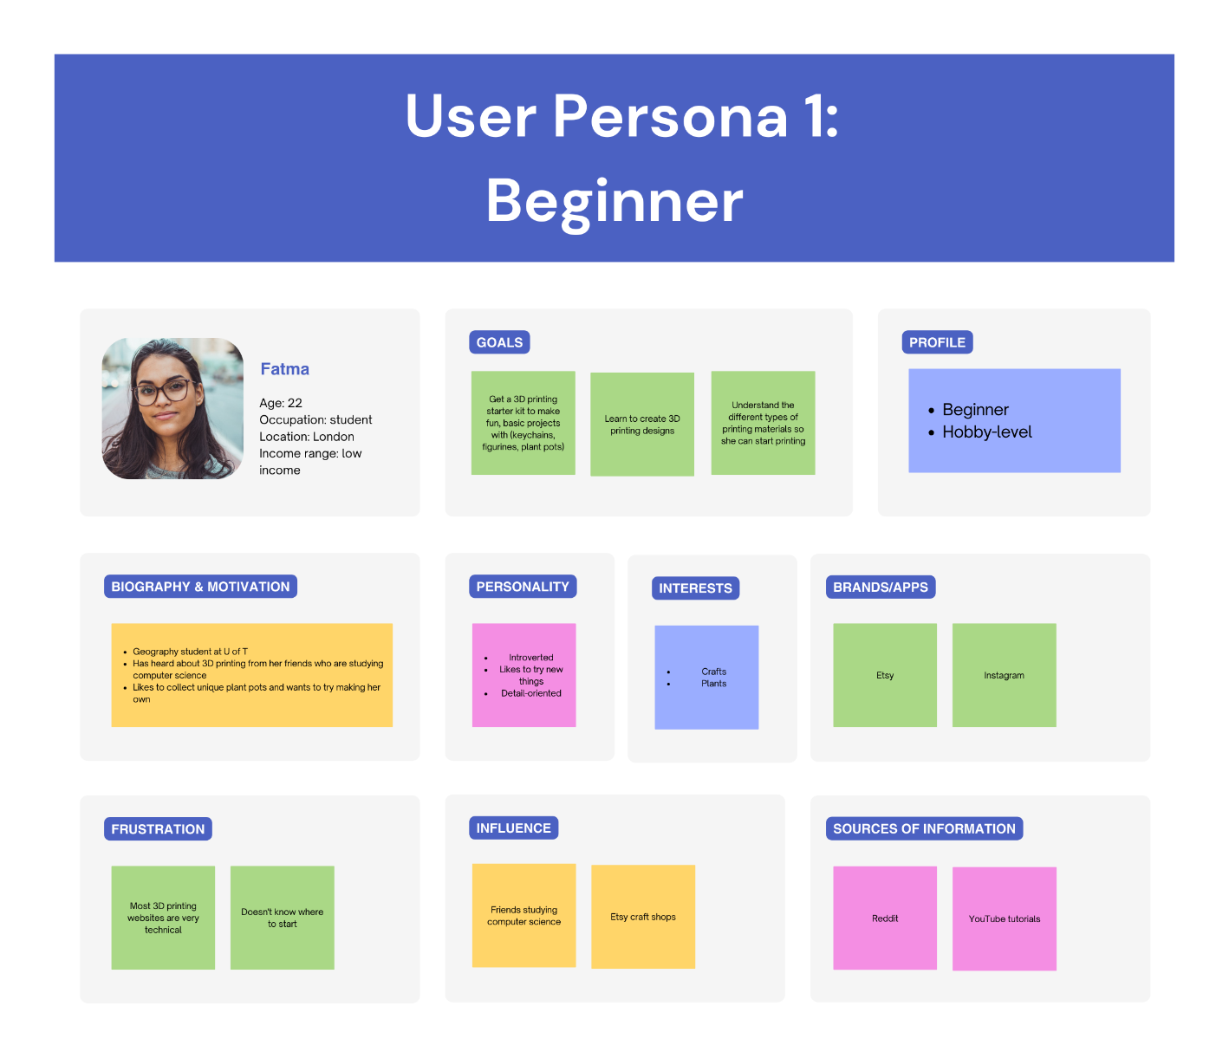

Figure 1: Detailed user persona for the Beginner

The Beginner starts their journey by discovering the Free3Dm e-commerce website through a Google search for businesses to help get started with 3D printing. From there, the user views the promotional content on the front page of the website and engages with the “Getting Started” page. The user gains a basic understanding of 3D printing and printing materials, and is guided towards purchasing basic, starter level products. The user journey for the Beginner is shown in Figure 2.

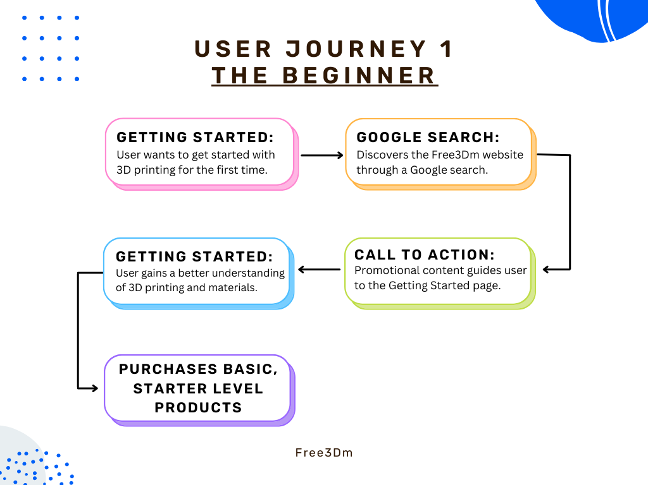

Figure 2: Flow chart displaying the user journey for the Beginner

### User Persona 2: The Hobbyist

The Hobbyist is interested in creating custom 3D printed products to sell online in their spare time, as a secondary source of income. They are looking for an e-commerce website where they can purchase filaments for multiple applications in one convenient place. The Hobbyist’s knowledge of 3D printing is at an intermediate level, and they have some specialised needs as a small business. The Hobbyist likes to take on challenges with their 3D printing projects and wants to expand their online store to include custom-made projects. They are frustrated with the current 3D printing e-commerce websites in the market and want to find a source for many different types of 3D printing products. More details about the Hobbyist user persona are shown in Figure 3.

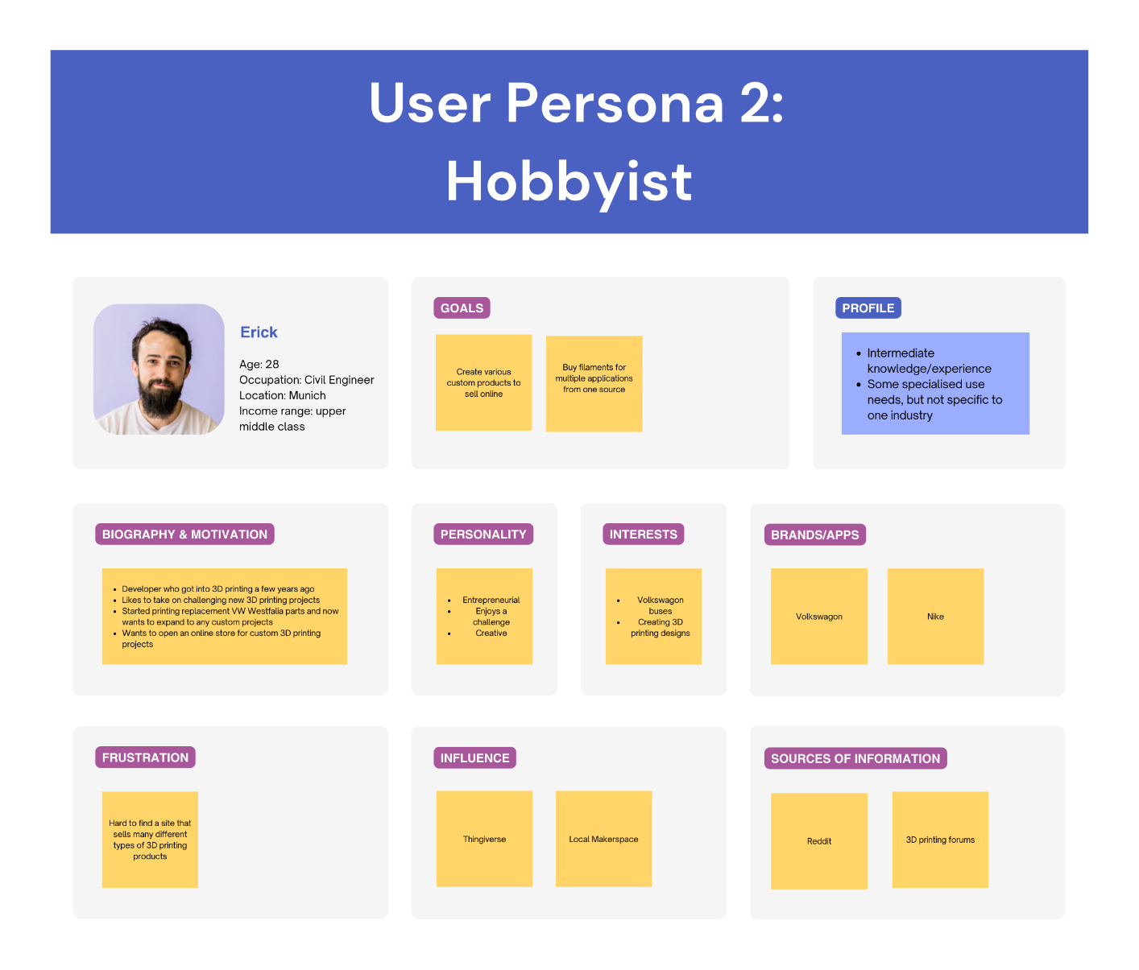

Figure 3: Detailed user persona for the Hobbyist

The Hobbyist has experience with 3D printing and owns some 3D printing products and materials. They locate the Free3Dm e-commerce website through the recommendation of a fellow 3D printing hobbyist in an online forum. The Hobbyist is knowledgeable and can navigate straight to the products they would like to purchase using the website’s top navigation header. They use detailed descriptions of the products to make decisions about which products are right for their current needs. The user returns to the Free3Dm e-commerce website regularly to make purchases to fulfill their small business custom orders and hobby projects. The user journey for the Hobbyist is shown in Figure 4.

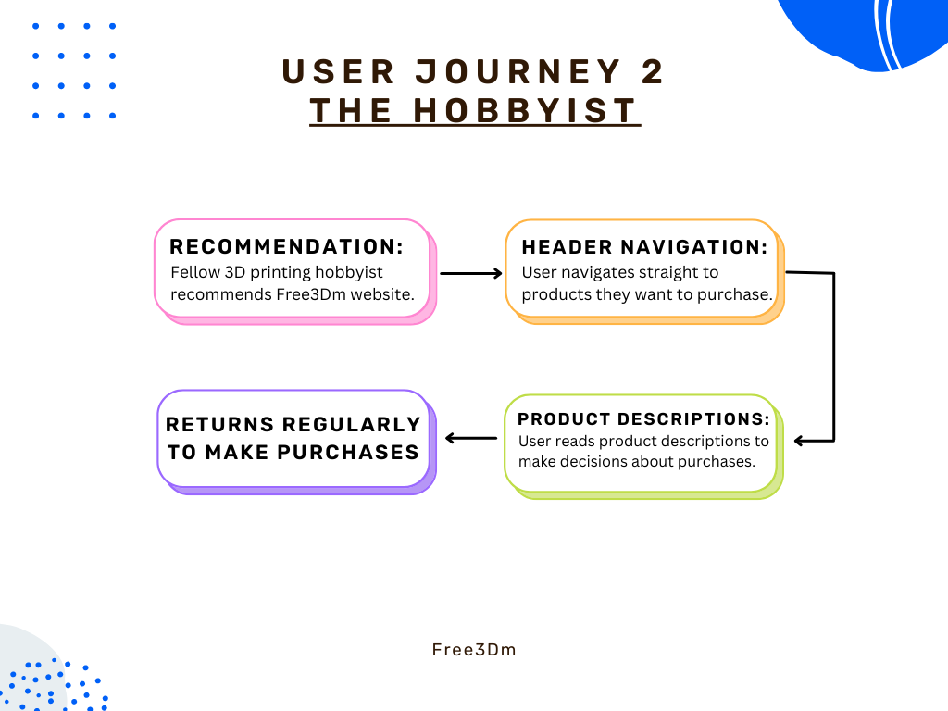

Figure 4: Flow chart displaying the user journey for the Hobbyist

### The Specialised Business Owner (User Persona 3)

The Specialised Business Owner wants to grow their business and is looking for a new supplier of high-quality 3D printing products. They have specific needs and an elevated level of knowledge of 3D printers and printing materials. They use 3D printers to create a wide range of products for local dental offices and would like to make bulk purchases on a regular basis. They are looking for a 3D printing e-commerce website that is professional and trustworthy enough to purchase high quality, medical-grade products from. More details about the Specialised Business Owner user persona are shown in Figure 5.

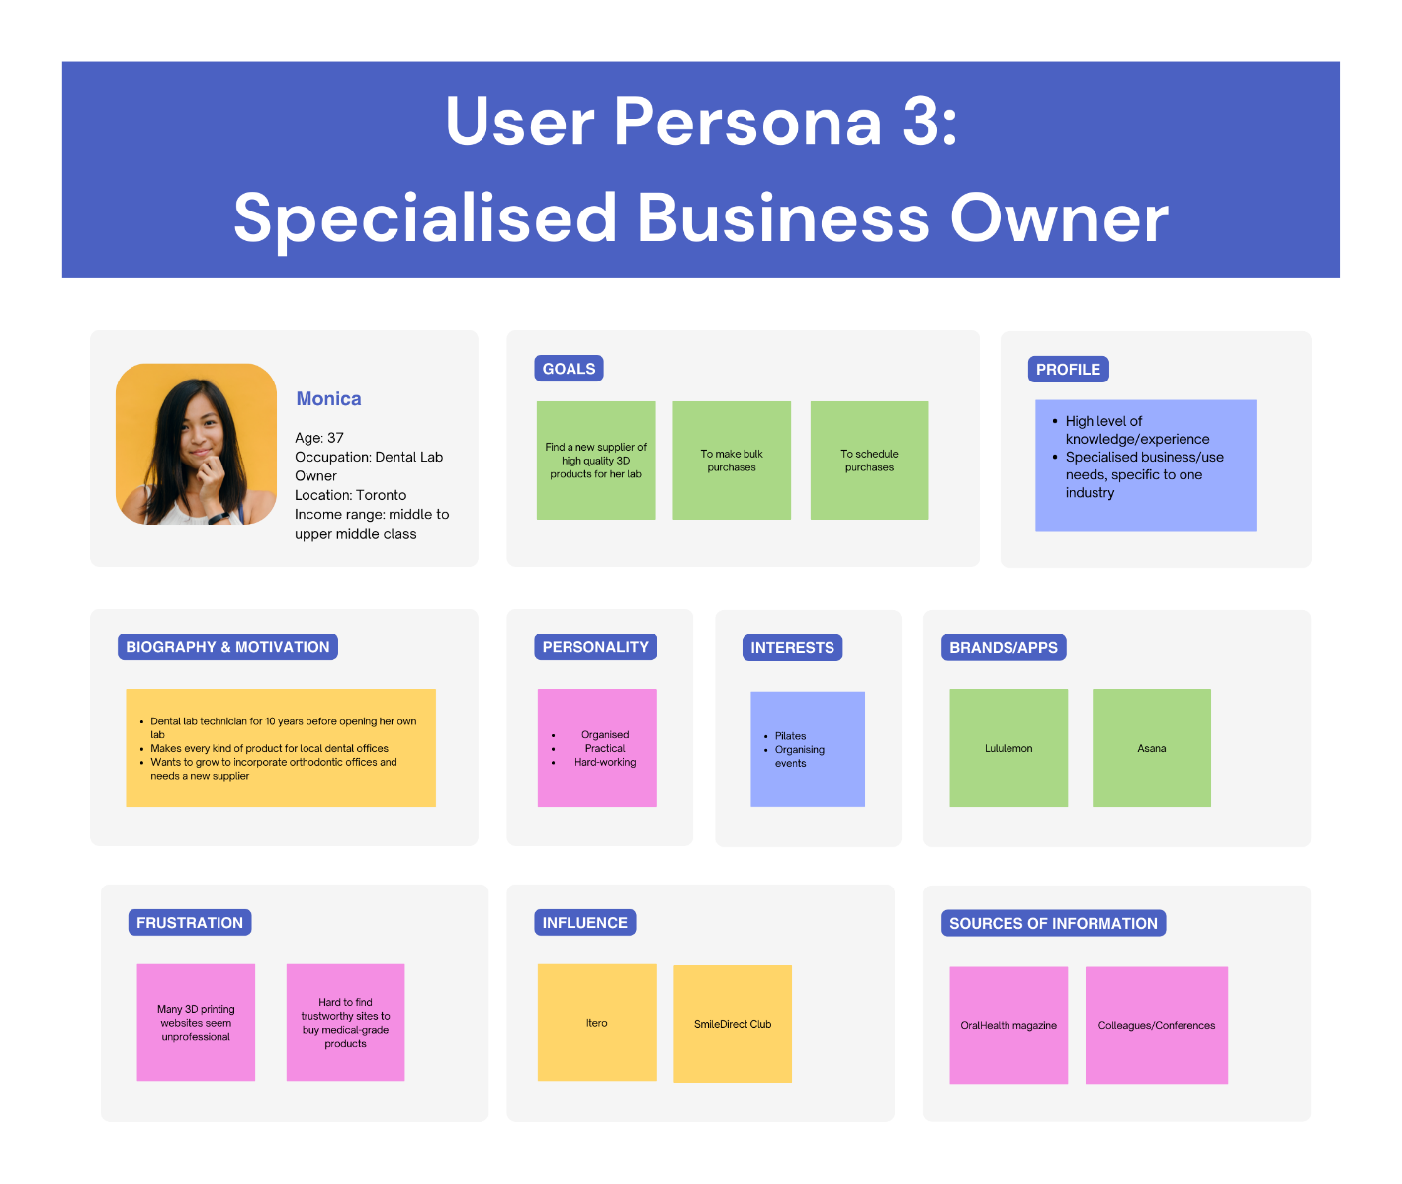

Figure 5: Detailed user persona for the Specialised Business Owner

The Specialised Business Owner locates the Free3Dm e-commerce website through the recommendation of another business owner in the industry. The user navigates to the footer of the website and learns more about the company, and the policies for orders, delivery, returns, and product warranties. The user then navigates directly to the products they would like to order from the navigation header. They see that they can purchase in bulk and use the product descriptions to ensure that they are purchasing products with the correct qualities. They continue to use the Free3Dm e-commerce website to supply their 3D printing business needs for a prolonged period. The user journey for the Specialised Business Owner is shown in Figure 6.

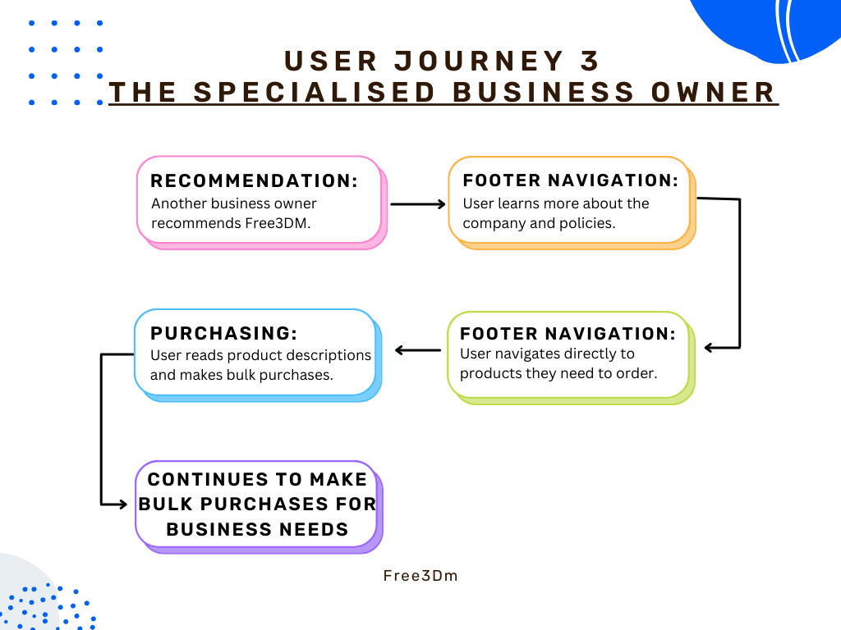

Figure 6: Flow chart displaying the user journey for The Specialised Business Owner user

# Deliverables

The Technical Communication team will produce the documentation and web content for the version 1.0 release of Free3Dm’s E-Commerce Website.

## List of Content Deliverables

Table 1lists the content deliverables (documents and web content) scheduled for the version 1.0 release.

| **Document #** | **Document Title** |
| --- | --- |
| COI-010 | Free3Dm E-Commerce Website 1.0 Documentation Plan |
| COI-020 | Free3Dm E-Commerce Website 1.0 Product copy (web-based content) |
| COI-030 | Free3Dm E-Commerce Website 1.0 Tutorial copy and script |
| COI-040 | Free3Dm printed full-colour merchandise catalogue |

Table 1: *List of documents scheduled for this release*

# Content Overview and Organisation

The following sections outline the main content areas of the Free3Dm website.

## UI content

The Technical Communication team will contribute the following areas, shown in Table 2, of web content for the version 1.0 release of the Free3Dm e-commerce website.

| **Content** | **Details** |
| --- | --- |
| Promotional text | Marketing and promotional text on the landing page of the website to attract customers and serve as a call to action. |
| “Getting Started” guide | A short “Getting Started” page that provides guidance to beginner users who want to know where to start.  A call to action for purchasing products to get started on their 3D printing. |
| Product descriptions | Product descriptions for 3D printers, filaments, resins, toys, and accessories that the Free3Dm website sells. Descriptions include difficulty level of product, food safety information, recommended usage, and pros and cons. |
| Buttons | All text on buttons throughout the website. |
| Tooltips | All written tooltips that display when the user hovers over sections or items on the website. |

Table 2: List of UI content that the Technical Communication team will contribute

| **Content** | **Details** |
| --- | --- |
| Error messages | Messages include information about incorrect email formatting, registered emails, incorrect password/username, email/username doesn't exist, user has already signed up (newsletter subscription), and confirmation for unsubscribing. |
| Drop-down menus | Headings and text for drop-down menus such as the main navigation header and associated drop-down menus (Printers, Filaments, Resin, Toys, Accessories), and additional drop-down menus throughout the website. |
| Dialogue boxes | Written content for dialogue pop-up text, including notifying users that items have successfully been added to their cart or wish list, or their order has successfully been placed. |
| Footer content | Written content for pages linked in the footer (Order & Delivery, Payment, Returns, Warranty & Repair, Company Details/About Us, Sustainability, Frequently Asked Questions, Privacy Policy, Terms and Conditions). Written content also includes company contact information (email, phone numbers), and customer service operational hours. A line about this project being for educational purposes will be added to the footer. |
| Bottom of page banner | Information about the current page located at the bottom of each page before the footer. |
| Customer review text | Written content to fill customer review sections for each product page. |
| Online Tutorial | Written instructional content and annotations for the introductory spotlight tutorial that walks users through the basic features of the website. |
| Printed Catalogue | Product descriptions and promotional/marketing text for the printed catalogue of products. A PDF version will also be available on the website. |

Table 2: List of UI content that the Technical Communication team will contribute (continued)

## Tutorial

The tutorial content includes written instructional content and annotations for the introductory spotlight tutorial that walks users through the basic features of the website.

The outline of the tutorial is as follows:

* + 1. **Welcome to Free3Dm** – highlights the logo and the header
    2. **Navigation bar** – highlights the different categories (printers, filaments, resin)
    3. (*Move to product page*) **Filter menu** – highlights the different filters (for example, customer rating, diameter, brand, material, etc.)
    4. **My wish list** – highlights the wish list feature and how to add an item to the wish list
    5. **My account** – highlights making an account to save your wish list and for a faster checkout
    6. **My cart** – highlights adding items to and viewing the shopping cart

## Catalogue Organisation

The content of the printed catalogue includes product descriptions and promotional/marketing text for products sold on the Free3Dm website.

**Organisation of the Catalogue**

The catalogue will be organised with a cover page and a table of contents split into categories for each product type. The table of contents will include coloured tabs on the side for quick and easy navigation.

**Sections of the Catalogue**

The catalogue will be divided into the following sections:

* + - Short company description or “About Us” section
    - Short “Getting Started” section that is a concise version of the associated website content
    - Printer products
    - Filament products
    - Resin products
    - Accessory products including replacement parts and filament holders
    - Business section for specialised products and printers that are best for high production
    - Advertisement/promotional text for the Free3Dm website, including the benefits of making an account
    - Customer support information, including contact information and hours of operation

**Design of the Catalogue**

The catalogue will be designed and created in Adobe InDesign and printed using The Printing House (TPH) professional printing services.

The following aspects will be included in the catalogue design:

* + - Magazine-style, including glossy pages and full-colour product pictures
    - Organisation by product type
    - Coloured tabs for navigation throughout the catalogue

# Content Strategy

This section describes Free3Dm’s overall strategy for the catalogue, tutorial, and web content.

## Usability

This section outlines the usability goals and strategy for the version 1.0 release.

### Usability Goals

In addition to a usable UI, the web content, tutorial, and catalogue must effectively assist users in completing tasks. The UI copy will help users navigate the website efficiently as it will clearly lead the users’ journey through the website. The web content, like the "Getting Started” guide, contact, and returns and shipping information will clearly communicate to the user the information that they need. The link text will tell the users what to expect and each standalone page of web content will be easily scannable with clear headings.

The tutorial will provide a high-level overview of the website by guiding the users through the navigation flow. The terminology in the tutorial copy will match what is used on the website.

The catalogue content will be scannable, findable, and readable by using a table of contents, index, colour-coded sections, clear headings, and short descriptions. This will ensure that users can find information quickly and easily.

**How the content assists users in performing tasks**

The UI, web, tutorial, and product catalogue content assists users in performing tasks in the following ways:

* The promotional banners and text guide users towards new or sale products.
* The recommended and related product collections guide users toward products that match their profile history.
* The beginner guide helps beginners choose products that fit their needs by empowering them to understand the product categories.
* The clear category and filter labels easily guide users to the type of products they need.
* The tutorial sets up the user to quickly start using the website effectively.
* The catalogue allows users to quickly find the relevant section by using predictable and easy navigation.
* The catalogue will also serve as a reference for the specialised business owner who may keep the printed version in their office to easily refer to products.

### Usability Testing

The Technical Communication team will ensure that the product content and documentation are usable by conducting usability testing within the time constraints of the project schedule.

We will conduct rounds of testing when:

* the prototype is complete.
* the website is complete.
* the content is finalised.

User testing will be completed using volunteers who are not familiar with the project and who fit into the user personas outlined in 1.4 Target Audience. Our test volunteers are:

* **Phil Walker**—a beginner with limited knowledge of 3D printing
* **Randy Britnell**—an intermediate-level 3D printer who is currently printing and selling figurines, but wants to expand to different materials
* **Michael Lino**—a Registered Dental Technician and Laboratory Manager at Shaw Lab Group in Toronto with a high level of experience with 3D printing

The types of testing we will conduct include:

* **Card sorting**—To be completed with the website prototype to determine whether the proposed IA and user journey match the users’ expectations. The results will also inform the design of the product catalogue.
* **Website user testing**—To be completed with the prototype and final website usability tests. Users will complete a set of standard tasks to ensure that the UI, web copy, and tutorial are effective. We will gather both quantitative and qualitative data by timing the users as they complete tasks, asking the users questions using a Likert scale after completing the tasks, and by interviewing the users after completing the tasks to clarify their behaviours.
* **Catalogue user testing**—To be completed with the catalogue draft before finalising for print. Users will complete a set of standard tasks to ensure that the organisation, format, and content are effective. We will gather both quantitative and qualitative data by timing the users as they complete tasks, asking the users questions using a Likert scale after completing the tasks, and by interviewing the users after completing the tasks to clarify their behaviours.

The development team will also ensure usability by doing the following:

* Test the website page loading speed using Google PageSpeed
* Test that the website is compatible with all browser types

### Usability Criteria and Measuring Success

Based on the user personas outlined in 1.4 Target Audience, Free3Dm’s audience is computer-literate and experienced with using e-commerce websites and PDFs in general.

This consideration informs the following usability criteria, which will be used in all rounds of testing for all formats:

* + - We will offer support only if the user asks. Table 3outlines the rubric for measuring the usability against the number of times the user asks for guidance.

| **Number of times user requests support** | **Type of support to be given** | **Usability grade** |
| --- | --- | --- |
| 0 | N/A | Excellent |
| 1 | **Website:** direct the user to watch the tutorial again  **Card-sorting and catalogue:** re-phrase the task | Good |
| 2 | Answer the user’s question or give direct guidance | Fair |
| 3 | Move to the next task—the documentation should be revised | Poor |

Table 3: The rubric to measure usability based on the number of times users ask for guidance

* + - The time limit for completing a task is 30 seconds. Table 4outlines the rubric for measuring the usability against the user completion time.

| **Completion time** | **Usability grade** |
| --- | --- |
| <10 seconds | Excellent |
| 11-20 seconds | Good |
| 21-30 seconds | Fair |
| >30 seconds | Poor—the documentation should be revised |

Table 4: The rubric to measure usability based on the time it takes users to complete the task

We will compare the expected and the actual user journeys to inform the website navigation and the catalogue organisation. We will consider the content usable based on a grade of Excellent or Good and based on how closely the actual user journey matches the expected user journey. We will revise the documentation based on a grade of Poor or on a grade of Fair and all users disprove the expected user journey.

## Accessibility

The Free3Dm e-commerce website will strive to be as accessible as possible. The accessibility strategy will span web content, UI, and printed content.

### Web Content Accessibility

To ensure the successful use of screen readers on the Free3Dm website, the development team will limit the use of <div> and <span> elements in the HTML code of the website, and instead use elements such as titles, paragraphs, headings, sections, articles, headers, and footers that semantically represent the content. Using correct semantic structure within the website code will optimise the user interface for screen readers.

The Free3Dm website will be responsive and accessible from mobile devices and larger screens. This strategy will include having different navigation type options for the user to choose from. Users will be able to navigate the website using their computer mouse, trackpad, or touch screen. Users will also be able to use their computer keyboard to navigate the website.

An accessibility tester will be used to ensure that colours used on the website are accessible and readable. Background, foreground, and text colours will have a high contrast to ensure that text is readable. All text on the website will be at least 1 rem in size, equivalent to 16-point font. Sans serif fonts will be used for increase clarity and readability.

All images used on the website will contain descriptive alternative text. All links will contain descriptive link text.

Overall, the written content on the website will be clear, consistent, and in plain language. Terms will be used consistently throughout the website to avoid confusion. Refer to Appendix Afor a list of terminology used throughout the Free3Dm website.

### Printed Catalogue Content Accessibility

To ensure that the printed catalogue is accessible for readers the background, foreground, and text colours will have high contrast colouring to ensure that text is readable. Large fonts will be used, with no text being smaller than 14-point for product descriptions. Sans serif fonts will be used to increase readability.

Images used in the printed catalogue will be large, consistent in sizing, and in full colour. See 5.4 Graphics for the complete specifications.

Overall, the written content will be clear, consistent, and in plain language. Terms will be used consistently throughout the catalogue to avoid confusion.

## Single Sourcing

Free3Dm’s single-sourcing strategy allows the Technical Communication team to reuse content in multiple places, contexts, and outputs. Maintaining only the source content increases consistency and accuracy across all uses.

Areas that can be reused across all content include:

* Product descriptions, which can be re-used in two ways:
  + Product descriptions for filaments where the base description is the same and the only difference is the colour
  + Product descriptions for the web and the catalogue
* The company “About Us”
* The company logo

The Technical Communication team will reuse information effectively and leveraging content to its fullest potential by doing the following:

* The catalogue will use single-sourcing principles to produce a print version for all audiences and PDF versions for each audience.
* For future iterations of the website, we would like to include more guides to materials and products, and the descriptions will be reused to supplement the material.
* Marketing and advertising content can reuse promotional text and product titles/headings.
* We will manage content in an XML editor that pushes updates to the project’s GitHub repository. This allows different output formats while keeping all content current.
* Images will be kept in the project’s GitHub repository in a folder system that is organised by product category.
* The InDesign print catalogue file will reference the GitHub repository folder system for images to ensure relevance.

## Localisation

The first iteration of the Free3Dm e-commerce website will be localised for all English-speaking audiences. As the company grows, Free3Dm will invest resources in creating a localisation and translation team to accurately localise and translate content.

### Localised Content Standards

Localised text will use the target locale’s date and time format, units of measurement, and currency. The text will avoid any cultural references, idioms, and colloquialisms, and limit humour.

The branding colours and colour combinations will be considered during localisation to avoid any offensive colours or colour combinations.

### Converting Labels

Products with English labels will be translated into the languages relevant to the locations where the product is approved to be sold. Since the label content is coming from a third-party manufacturer, the translation will also be provided directly on the Free3Dm website.

### Converting Units of Measurement

Conversion of units of measurement will be automatically localised on the website through code implementation. The Free3Dm website will automatically collect data from the user’s browser and determine the user’s location using their IP address. Units of measurement will automatically adjust based on this information.

### Localisation Resources and Costs

As the first iteration of the Free3Dm website will be localised for English-speaking locations only, the localisation effort will be done internally through research and consulting experts. Depending on the target region, the localisation may need to be outsourced to provide the most accurate outcome.

Future iterations of localisation efforts will be outsourced to localisation and translation companies, with an expected cost of $20-$40 per hour per individual, and an expected translation rate of one hour per written page of content.

# Specifications

This section describes the platforms, tools, design implications, graphic requirements, delivery format, and style conventions for the content in the Free3Dm E-Commerce Website release version 1.0.

## Platforms

The Free3Dm website will offer multi-platform support and allow users to access it on any system, browser, and device.

The website will use responsive design so users can interact with it on any device and still have a valuable experience. The responsive design will set the viewport to ensure an optimised experience regardless of the device, including during interaction with text, images, and menus.

The introductory spotlight tutorial will be available on the website on the first interaction with the website. In subsequent interactions with the website, the tutorial will not appear automatically, but it will be available for the user to rewatch if needed.

The catalogue will be available on the site as a PDF download for customers. Additionally, customers will be able to request a free copy of the printed catalogue from the site’s contact page.

## Tools and Equipment

Our team will author content, and create graphics, flowcharts, and wireframes using the tools outlined in Table 5. Other tools may be used for project management and communication purposes throughout the development of the Free3Dm website. All tools will be free to access or accessible to the team through Seneca College.

| **Tool** | **Purpose** |
| --- | --- |
| Canva | To create user personas, user journey flow charts, and company logos. |
| Linear | Project management tool for organising a backlog, planning sprints and cycles, and assigning tasks to cross-functional team members. |
| Adobe XD | To create website wireframes. |
| Adobe InDesign | To design and create the print catalogue and company logos. |
| Adobe Photoshop | To edit images for the Free3Dm website and printed catalogue. |
| Microsoft Word | To create drafts and final copies of written content. |
| OneDrive | To collaborate on the Free3Dm E-Commerce Website version 1.0 Documentation Plan. |
| GitHub | Collaboration tool for shared file storage and version control. |
| Zoom | Communication tool for scheduled group and class video calls. |
| Discord | Communication tool for daily written team communication, updates, follow ups, and scheduling. |
| WebStorm | Development software for coding in HTML, CSS, and JavaScript. |
| DataGrip | Database management software. |

Table 5: List of tools required for the project and the purpose of each

## Design Implications

Table 6outlines the three different users who we expect to interact with the Free3Dm e-commerce website and the tasks that they perform on the website. Refer to 1.4 Target Audience for more detailed user personas and user journeys.

| **User** | **Tasks** |
| --- | --- |
| The Beginner | * Learn about the different products and associated uses through the “Getting Started” page * Order fun products such as pens and filaments * Order a product starter kit * Create an account * Subscribe to the newsletter for a discount on the first order |
| The Hobbyist | * Order products on a semi-regular basis to fulfill small custom orders for a side-business * Learn about and order specialised and intermediate level products * Order accessories such as new nozzles and belts |
| The Specialised Business Owner | * Order professional products, refills, and accessories on a regular basis to fulfill small to medium business needs * Place bulk orders * Make scheduled purchases * Subscribe to the newsletter for a discount on the first order * Create an account |

Table 6: The target audience for the Free3Dm e-commerce website and the associated tasks

### Website Design Implications

The Free3Dm website aims to look professional for the Hobbyist and Specialised Business Owner audiences, while also remaining unintimidating for the Beginner audience. The website will be intuitive and easy to navigate to avoid overwhelming new users and beginners and to retain users.

Each part of the audience has a different user flow and journey. These journeys will be considered in the website design process to ensure that the website is usable by all audiences. The aim of the website design is to provide a seamless experience for different members of the audience.

### Writing Tone

Written content and promotional text will be formal to align with the professional tone of the website. The content and tone will be more fun and informal for novelty product, toy descriptions, and promotional text, to capture the attention of beginners.

The online tutorial will be aimed at beginners. Written content will have a friendly, inviting tone that is less formal than the rest of the written content on the website. The online tutorial must keep the user engaged so that they finish the tutorial and continue to interact with the Free3Dm website.

The printed catalogue will be aimed at regular and professional users. The written content will be short, concise, and have a professional tone.

## Graphics

Graphics will be optimised based on the output and will follow the specifications for each output.

### Website Graphics

Colours will use RGB values. Product images will use the following specifications:

* Smooth edges with no borders
* Transparent background
* 72 DPI

### Printed Catalogue Graphics

The catalogue will be available in print and PDF formats. However, we expect users to print the PDF catalogue. Colours will use CMYK values.Product images will use the following specifications:

* + - 1-point straight border (no beveled or jagged edges)
    - Conform to a standard square size of 2” by 2” and be separated by at least 0.125”
    - 300 DPI

The “Getting Started” page will have callouts on the products with the following specifications:

* 2-point width
* Red arrows point to the text

## Delivery Format

Table 7 specifies the delivery format for the final version of each deliverable listed in 2.1 List of Content Deliverables.

| **Document #** | **Document Title** | **Delivery Format** |
| --- | --- | --- |
| COI-010 | Free3Dm E-Commerce Website 1.0 Documentation plan | Written in .docx format and converted into Adobe PDF (.pdf) for final delivery. |
| COI-020 | Free3Dm E-Commerce Website 1.0 Product copy (web-based content) | Written in .rtf or .docx format and uploaded to the project’s GitHub repository in the “Content” folder. |
| COI-030 | Free3Dm E-Commerce Website 1.0 Tutorial copy and script | Written in .rtf or .docx format and uploaded to the project’s GitHub repo (“Content” folder). |
| Free3Dm E-Commerce Website 1.0 Tutorial | Online in the Free3Dm e-commerce website. |
| COI-040 | Free3Dm printed full-colour merchandise catalogue | Perfect bound with a glossy finish. |
| Free3Dm online full-color merchandise catalogue | Published and exported into Adobe PDF (.pdf) format and available online on the Free3Dm e-commerce website. |

Table 7: List of deliverables and final delivery format

## Style and Terminology

The Technical Communication team follows the [Microsoft Style Guide](https://learn.microsoft.com/en-us/style-guide/welcome/) for all written content across deliverables.

Free3Dm’s voice and tone are professional, trustworthy, and welcoming. The writing avoids the use of overly technical language and jargon when possible; however, 3D printing as a field has its own set of technical terminology. When technical language cannot be avoided, the terms will be defined in context. See Appendix A for the terminology list.

The development team follows best practices for naming conventions and semantic structure, which is outlined on W3 Schools here: <https://www.w3schools.com/html/html5_syntax.asp.>

# Project Schedule

This section contains information about the overall project schedule including plans for post-release change control.

## Project Milestones

Table 8 outlines the milestones and dependencies for each deliverable in the version 1.0 release.

| **Milestone** | **Date** | **Deliverable** | **Dependencies** |
| --- | --- | --- | --- |
| Documentation Plan | October 18 | Free3Dm E-Commerce Website 1.0 Documentation Plan | * All required information and approval from the development team |
| Free3Dm E-Commerce Website 1.0 | November 8 | Free3Dm E-Commerce Website 1.0 Product copy (web-based content) | * Finalised wireframes and prototype * Finalised product list |
| Free3Dm E-Commerce Website 1.0 Tutorial copy and script | * Finalised feature list for the pages being highlighted in the tutorial |
| Free3Dm Product Catalogue | December 6 | Free3Dm printed full-color merchandise catalogue | * Finalised company branding, including the final logo * Finalised product list |

Table 8: The deliverables and associated project milestones, due dates, and dependencies

## Reviews and Approvals

Table 9outlines the required review and approval process for each milestone, including the names and roles of those responsible.

| **Document #** | **Document Title** | **Reviewers** | **Approvers** | **Date approval needed** | **Date approvals completed** |
| --- | --- | --- | --- | --- | --- |
| COI-010 | Free3Dm E-Commerce Website 1.0 Documentation Plan | * Nazdar Sadik (Technical Writer) * Gloria van Trigt (Technical Writer) * Kilian de Bock (Developer, SME) | * Amy Briggs (Project Lead) | October 18 |  |
| COI-020 | Free3Dm E-Commerce Website 1.0 Product copy (web-based content) | * Nazdar Sadik (Technical Writer) * Gloria van Trigt (Technical Writer) * Kilian de Bock (Developer, SME) | * Nazdar Sadik (Technical Writer) * Gloria van Trigt (Technical Writer) * Kilian de Bock (Developer, SME) | October 18 |  |

*Table 9: List of documents with associated approvals*

| **Document #** | **Document Title** | **Reviewers** | **Approvers** | **Date approval needed** | **Date approvals completed** |
| --- | --- | --- | --- | --- | --- |
| COI-030 | Free3Dm E-Commerce Website 1.0 Tutorial copy and script | * Nazdar Sadik (Technical Writer) * Gloria van Trigt (Technical Writer) * Kilian de Bock (Developer, SME) | * Nazdar Sadik (Technical Writer) * Gloria van Trigt (Technical Writer) * Kilian de Bock (Developer, SME) | October 25 |  |
| COI-040 | Free3Dm printed full-color merchandise catalogue | * Nazdar Sadik (Technical Writer, Designer) * Gloria van Trigt (Technical Writer, Designer) | * Nazdar Sadik (Technical Writer, Designer) * Gloria van Trigt (Technical Writer, Designer) | **PDF approval:** December 6  **Print approval:** December 14 |  |

Table 9: List of documents with associated approvals (continued)

## Production and Distribution

Table 10outlines the printing and distribution details for the documents and content produced for this project.

| **Document #** | **Document Title** | **Printing** | **Distribution** |
| --- | --- | --- | --- |
| COI-010 | Free3Dm E-Commerce Website 1.0 Documentation plan | * N/A | * Distributed electronically to the Project Lead for review and approval |
| COI-030 | Free3Dm E-Commerce Website 1.0 Tutorial copy and script | * N/A | * Integrated into the Free3Dm e-commerce website and available for customers to view repeatedly |
| COI-040 | Free3Dm printed full-color merchandise catalogue | * Packaged into PDF format from InDesign * Printed by Free3Dm using The Printing House (TPH) print services * TPH printing specifics include perfect bound, glossy pages, and 100 lb. text gloss paper weight * Approximate cost for one copy $62.00, additional copies $17.00 | * Distributed by mail to customers who request the catalogue through the Free3Dm website * Available for users to view online and print through the Free3Dm website |

Table 10: List of documents with associated printing and distribution details

## Maintenance and Change Control

Maintenance and changes will be managed using the following change management process:

1. Plan/Scope
2. Assess/Analyse
3. Review/Approval
4. Build/Test
5. Implement
6. Close

Table 11explains the actions and the responsible person or team within each step.

| **Change management step** | **Actions** | **Responsible Person(s)** |
| --- | --- | --- |
| 1. Plan/Scope | Assign sections of content and documents for review prior to the version 1.0 release. | * Documentation Manager |
| Review all written content before and after version 1.0 release to identify bugs and propose changes. | * Technical Communication Team * QA Team |
| Create an issue in Linear for each issue, bug, or typo and bring to the attention of the team at the end of the current cycle to further assess. | * Technical Communication Team * QA Team |
| Assign a technical writer to correct the issue, bug, or typo. | * Documentation Manager |
| Establish start and end dates for the Technical Communication team to complete the correction/change. | * Documentation Manager |
| 2. Assess/Analyse | Analyse the issue within the scope of the overall project to ensure changes do not impact other documents or parts of the project. | * Documentation Manager * Technical Communication Team |

*Table 11: The maintenance and change management process, steps, and responsible person(s)*

|  |  |  |
| --- | --- | --- |
| **Change management step** | **Actions** | **Responsible Person(s)** |
| 2. Assess/Analyse | If changes will impact other content, alert the Technical Communication team that further changes must be made to keep content consistent. | * Documentation Manager * Technical Communication Team |
| Designate the proposed change as high, moderate, or low risk.   * High-risk changes require approval and understanding from all team members. * Low-risk changes can be made directly by the Technical Communication team. | * Documentation Manager * Technical Communication Team |
| 3. Review/Approval | Review the change. The Development Team will review changes that affect the structure of the Free3Dm website. | * Technical Communication Team * Development Team |
| Approve the change. | * Documentation Manager * Project Lead |
| 4. Build/Test | Assign the approved change to individuals within the Technical Communication team. | * Documentation Manager |
| Add tasks to the backlog in Linear and assign tasks to the relevant team members. | * Technical Communication Team * Development Team |
| Set internal deadlines to test changes so that content can be reviewed and tested on the Free3Dm website before the changes are implemented. | * Technical Communication Team * Development Team |
| 5. Implement | Implement the completed, approved changes | * Technical Communication Team * Development Team |

*Table 11: The maintenance and change management process, steps, and responsible person(s) (continued)*

|  |  |  |
| --- | --- | --- |
| **Change management step** | **Actions** | **Responsible Person(s)** |
| 6. Close | Review the final implementation of written content. | * Technical Communication Team * Documentation Manager * QA Team |
| Review the final implementation of development content. | * Development Team * Development Manager * QA Team |
| Close the change request. | * Documentation Manager * Project Lead |

Table 11: The maintenance and change management process, steps, and responsible person(s) (continued)

# Resources

## Technical Writers

Table 12below outlines the deliverables and members of the Technical Communication team who are responsible for specific sections of each deliverable.

| **Document #** | **Deliverable** | **Responsibilities/Sections** | **Name** |
| --- | --- | --- | --- |
| COI-010 | Free3Dm E-Commerce Website 1.0 Documentation Plan | * 1. Introduction (1.1, 1.2, 1.3, user personas) * 2. Deliverables * 3. Content Overview and Organization (3.2) * 4. Content Strategy (4.1, 4.3) * 5. Specifications (5.1, 5.4, 5.5, 5.6) * Project Schedule (6.1, 6.2, 6.4) * 7. Resources (7.2) * 8. Dependencies * 10. Documentation Plan Revision * 11. Appendix (Terminology List) * All sections: Reviewing and editing | Gloria van Trigt |
| * 1. Introduction (1.4, user journeys) * 2. Deliverables * 3. Content Overview and Organization (3.1, 3.3) * 4. Content Strategy (4.2, 4.4) * 5. Specifications (5.2, 5.3, 5.5, 5.6) * 6. Project Schedule (6.1, 6.2, 6.3) * 7. Resources (7.1, 7.3) * 9. Risks and Issues * 10. Documentation Plan Revision * 11. Appendix (Terminology List) * All sections: Reviewing and editing | Nazdar Sadik |

Table 12: List of Technical Communication deliverables and responsibilities

|  |  |  |  |
| --- | --- | --- | --- |
| **Document #** | **Deliverable** | **Responsibilities/Sections** | **Name** |
| COI-020 | Free3Dm E-Commerce Website 1.0 Product copy (web-based content) | * Promotional text * “Getting Started” page * Product descriptions (printers, resins, accessories) * Drop-down menu text * Banner text at the bottom of each page * Customer Review text | Gloria van Trigt |
| * Product descriptions (filaments, pens) * Button text * Error messages * Dialogue boxes * Footer content (Order & Delivery, Payment, Returns, Warranty & Repair, Company Details/About Us, Sustainability, Frequently Asked Questions, Privacy Policy, Terms & Conditions, Contact Information & Hours | Nazdar Sadik |
| COI-030 | Free3Dm E-Commerce Website 1.0 Tutorial copy and script | * N/A | Gloria van Trigt and Nazdar Sadik |

Table 12: List of Technical Communication deliverables and responsibilities (continued)

|  |  |  |  |
| --- | --- | --- | --- |
| **Document #** | **Deliverable** | **Responsibilities/Sections** | **Name** |
| COI-040 | Free3Dm printed full-color merchandise catalogue | * Catalogue design and formatting in InDesign * Table of contents * Product descriptions * Introductory text * Index | Gloria van Trigt |
| * Catalogue design and formatting in InDesign * Product descriptions * Copyright information * “About Free3Dm” * Index | Nazdar Sadik |

Table 12: List of Technical Communication deliverables and responsibilities (continued)

## Stakeholders and Cross-Functional Team

Table 13 lists the contributors on the product team by title and name.

| **Name** | **Department/Role** | **Project Responsibilities** |
| --- | --- | --- |
| N/A | Development Manager | * Point of contact between client and upper management * Establish project milestones * Ensure the project is on schedule and within budget |
| N/A | Quality Assurance Lead | * Create the test plan * Run test cases to ensure the site meets the client’s requirements |
| N/A | Documentation Manager | * Lead and assign tasks to Technical Communication team * Give final approval on documentation deliverables * Maintain style guide and terminology list |
| N/A | Product Manager | * Develop and manage the project plan * Lead, manage, and assign tasks to the project team |
| N/A | Customer Support | * Point of contact for users * Passes on users’ pain points to the Development and Technical Communication teams |
| Gloria van Trigt | Technical Writer | * Write documentation plan, UI and web content, tutorial outline and copy * Design product catalogue * Gather information from SME |
| Editor | * Edit all written content for clarity, consistency, and usability * Ensure adherence to style guide and terminology list |

*Table 13: List of stakeholders and responsibilities*

|  |  |  |
| --- | --- | --- |
| **Name** | **Department/Role** | **Project Responsibilities** |
| Nazdar Sadik | Technical Writer | * Write documentation plan, UI and web content, tutorial outline and copy * Design product catalogue * Gather information from SME |
| Editor | * Edit all written content for clarity, consistency, and usability * Ensure adherence to style guide and terminology list |
| Kilian de Bock | Developer | * Front-end and back-end development * Create spotlight tutorial from the outline and copy created by the Technical Communication team |
| SME | * Provide explanation of site and products to Technical Communication team |

Table 13: List of stakeholders and responsibilities (continued)

## Subject Matter Experts

The development of the Free3Dm e-commerce website requires various subject matter experts (SMEs). The Technical Communication team will work with SMEs to gather the most accurate information about web design, 3D printing, software development, technical writing, and user needs. Table 14outlines the SMEs that we will consult and their responsibilities.

| **Name** | **Department** | **Responsibilities** |
| --- | --- | --- |
| Kilian de Bock | Development | * Knowledge of HTML, CSS, and JavaScript * Knowledge of web design and structure best practices * Knowledge of 3D printing products, services, and accessories |
| Amy Briggs | Project Lead | * Knowledge of software development best practices * Knowledge of technical writing best practices * Knowledge of InDesign best practices |
| N/A | Development Manager | * Knowledge of client needs * Knowledge of project budget |
| N/A | Quality Assurance Lead | * Knowledge of HTML, CSS, and JavaScript * Knowledge of web design and structure best practices * Knowledge of testing practices, bugs, and development changes |
| N/A | Customer Support | * Knowledge of user needs and pain points |

Table 14: List of subject matter experts and responsibilities

# Dependencies

Table 15lists the known dependencies for each deliverable in the Free3Dm E-Commerce Website version 1.0 release.

| **Document #** | **Document Title** | **Dependencies** |
| --- | --- | --- |
| COI-010 | Free3Dm E-Commerce Website 1.0 Documentation plan | * Input and approval by development team * Approval from stakeholders to move to next stage |
| COI-020 | Free3Dm E-Commerce Website 1.0 Product copy (web-based content) | * Completion and availability of the prototype (to write UI copy) * Finalised list of products (for product descriptions) * Approval of content accuracy by SMEs |
| COI-030 | Free3Dm E-Commerce Website 1.0 Tutorial copy and script | * Completion of the prototype * Interviews and feedback from SMEs |
| COI-040 | Free3Dm printed full-color merchandise catalogue | * Completion of single-sourced web copy (product descriptions, company About Us) * Finalised list of products and related images * Finalised company branding |

Table 15: List of dependencies for each deliverable

# Risks and Issues

There is a large difference in knowledge between the Technical Communication and Development teams. This knowledge gap may result in misunderstandings or miscommunication between teams as the Free3Dm website is developed. To reduce this issue, the Technical Communication and Development teams will remain in close contact and provide updates on work completed on a regular basis. Teams will meet virtually on Tuesdays and Wednesdays to discuss work completed, assign and create backlog issues, and use Linear to organise tasks for the upcoming cycles. Teams will communicate through messaging on Discord on Mondays to update all members on work completed and any issues.

Due to the tight timeline requested by the project lead and only having one developer on the project team, there is a risk that not all the optional features of the project will be implemented into the Free3Dm e-commerce website. The sole developer on the team will focus on completing the essential required features of the website within the timeline. Optional features will be implemented if there is time within the software development timeline.

# Documentation Plan Revisions

Table 16 documents the various revisions and iterations of the Free3Dm Documentation Plan.

| **Revision** | **Author** | **Summary of changes** |
| --- | --- | --- |
| 1 | Gloria van Trigt and Nazdar Sadik | Initial version |
| 2 | Gloria van Trigt and Nazdar Sadik | Updated in this version:   * Specifications for web graphics * Multi-platform and multi-browser compatibility * Development team usability testing for browser compatibility * Use of IP address to determine the user’s location instead of a splash page where user selects their country * New terms added to Appendix A: Terminology List * Section 4.2 Accessibility on website font size * Section 5.2 Tools and Equipment |
| 3 | Gloria van Trigt and Nazdar Sadik | Updated in this version:   * Revised for consistency * Edit for clarity |
| 4 | Gloria van Trigt | Updated in this version:   * Formatted headings and tables for consistency * Added cross-references for tables and figures * Added company logo |
| 5 | Nazdar Sadik | Updated in this version:   * Revised for consistency * Formatted table headings and captions * Formatted text and heading level alignment * Fixed spelling errors and typos |
| 6 | Gloria van Trigt | Updated in this version:   * Formatted sentences introducing lists * Added alt text * Ran editor check and accessibility and corrected issues |
| 7 | Nazdar Sadik | Updated in this version:   * Revised for grammar and spelling errors |

Table 16: Documentation Plan revisions

# Appendix A

## Terminology List

**Acrylonitrile butadiene styrene (ABS):** A durable filament for general purpose 3D printing. This filament material is strong, durable, and temperature resistant, but can be difficult to print with and emits harsh fumes.

**Additive manufacturing (AM)**: Another term for 3D printing, typically used to refer to industrial-level production.

**Build plate**: see **Print bed**.

**Computer-aided design (CAD)**: The use of computer software to design an object. CAD models are the instructions that 3D printers use to print objects.

**Curing**: Resin printers, like SLA printers, use a UV light or laser to harden the resin into solid structures.

**Enclosure**: Any kind of container that surrounds a 3D printer to control the temperature and environment during printing. Enclosures are required for printing with resin, like when using a FDM printer, to ensure a successful outcome.

**Extruder**: An important piece of an FDM printer, the extruder is a motor that pushes filament toward the hot end (see **hot end**).

**FEP sheet**: see **Interface layer**.

**Filament:** A material used in 3D printers to print with.

**Fused Deposition Modeling (FDM)**: FDM printers extrude filaments through a heated nozzle, which melts the material. It then applies the melted material onto the print bed to build the part layer by layer. FDM printers are among the most common printers used by consumers (vs. Industry); however, they are not able to print more complex designs as they have low accuracy.

**Hot end**: An essential part of FDM printers. The hot end heats the filament so it can be pushed through the nozzle. It maintains a consistent temperature to ensure the final product is successfully created.

**Interface layer**: The interface layer or FEP sheet is a lining for the bottom of print vats in SLA/DLP/LCD printers. The lining is a double layer, transparent film that allows the resin to be cured by the UV light during printing.

**Nozzle**: In FDM printers, the nozzle screws into the hot end. It conducts heat from the hot end to melt the filament and then extrudes the filament onto the print bed to form an object. Nozzles come in a variety of materials, sizes, and inner diameters.

**Nylon or Polyamide (PA):** A synthetic polymer used as a 3D printing filament material that is strong, flexible, and durable but must be stored in a cool, dry place.

**Polycarbonate (PC):** One of the strongest 3D printer filaments, extremely durable, resistant to physical impact, and heat. Does not shatter or crack under stress.

**Polylactic acid (PLA):** Thermoplastic polymer derived from renewable resources. One of the most popular types of 3D printing filaments, with a lower printing temperature and no off-putting odour.

**Polyethylene terephthalate (PET)/ Polyethylene terephthalate glycol (PETG):** One of the most used plastic materials. The PETG variant is used as a 3D printing filament material to create clearer, less brittle, flexible, durable, and temperature resistant projects.

**Print bed**: The print bed or build plate is the platform onto which the model is printed.

**Resin:** A material used in 3D printers to print with. Printing with resin involves using ultraviolet (UV) light to solidify resin into hard plastic.

**Selective Laser Sintering (SLS)**: SLS printers fuse small particles of powder into solid structures with a high-powered laser. The most common material used is nylon. SLS printers are typically used to create strong and functional prototypes.

**Stereolithography (SLA)**: SLA 3D printers harden resin into plastic by curing it with a laser or UV light. SLA printers are ideal for a wide range of uses, from quick prototyping to jewelry casting to dental applications. SLA printers were the first type of 3D printer.

**Thermoplastic elastomers (TPE):** Soft and stretchable plastic used for flexible 3D printing filament materials. This filament has rubber-like qualities and is ideal for projects that will experience a lot of physical wear. However, this material can be difficult to extrude.